**Find Best Path**

You are given a directed graph with N vertices (numbered 1 through N) and M weighted edges. For each vertex of the graph, find the minimum cost of a walk that passes through this vertex, or determine that the minimum does not exist, i.e. for any integer m, there is a walk with cost smaller than m.

**Notes:**

* A walk in a directed graph is a sequence of vertices v1,v2,…,vK for some positive integer K, and an associated (possibly empty) sequence of edges e1,e2,…,eK−1 such that for each valid i*i*, edge ei​ goes from vertex vi to vertex vi+1
* The cost of a walk is the sum of weights of edges e1,e2,…,eK−1; if K=1, the cost is 0.
* A walk *passes through* vertex u if u belongs to the sequence v1,v2,…,vK​.

**Input**

* The first line of the input contains a single integer T denoting the number of test cases. The description of T test cases follows.
* The first line of each test case contains two space-separated integers N and M.
* Each of the next M lines contains three space-separated integers u, v and w describing an edge from vertex u to vertex v with weight w.

**Output**

For each test case, print N lines. For each valid i*i*, if the minimum cost of a walk through vertex i*i* does not exist, the i*i*-th of these lines should contain the string "INF". Otherwise, it should contain a single integer — the minimum cost.

**Constraints**

* 1≤T≤501≤*T*≤50
* 1≤N,M≤1,0001≤*N*,*M*≤1,000
* ∣w∣≤106∣*w*∣≤106

**Subtasks**

**Subtask #1 (30 points):** 1≤N,M≤1001≤*N*,*M*≤100

**Subtask #2 (70 points):** original constraints

**Sample 1:**

Input

Output

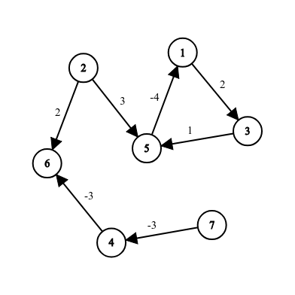1

7 7

1 3 2

5 1 -4

2 5 3

2 6 2

3 5 1

4 6 -3

7 4 -3

INF

INF

INF

-6

INF

-6

-6